

Bachelor of Engineering Thesis Project Proposal

Callum Rohweder

The Jaco Arm: Reaching out to V-REP through an Experimental Platform

Connecting Virtual Robotics to an Experimental Platform

August 24th, 2017

METR4901

Under supervision of Dr. Surya Singh  
  
Faculty of Engineering, Architecture and Information Technology

The University of Queensland

# Abstract

Contents

Abstract 1

Introduction 1

Background Advancements 1

Background of Project Related Material 4

V-REP 4

Kinova 5

Project Plan 6

Current Objectives 6

Possible Related Developments 6

Risk Assessment 6

Discussion 6

Conclusion 6

Bibliography 6

# Introduction

From the first robotic arms of Da Vinci’s mechanical knight in 1495 to the recent developments in remote robotic surgery, people have been trying to replicate human actions with autonomous systems for centuries. The current norm is that virtual communication only extends to two dimensional interaction through video, where someone can merely oversee an activity or speak to a colleague. Simulation environments which remotely control actuators, like that of a typical robotic arm, have the potential to allow the interaction on a physical level. This paper looks into the benefits this can possess and the current advancements. Additionally, it is proposed that using V-REP’s remote API, a simulated environment of a test laboratory with a Jaco Kinova arm can be generated, and movement replicated in the physical space. Thus, allowing physical interaction occur for real-time or predefined processes.

# Background Advancements

**Manufacturing and Process Lines**

**Simulating a process before implementation in the manufacturing industry has led to significant reductions in failure and cost. With the help of 3D CAD models, manufacturers of large capital equipment are able to test a procedure and optimize accordingly. Thus, it is possible to view the limitations of their systems before an error occurs, and design accordingly** [1]**. From a manufacturing prospective, it allows the (physical) machining of materials to be done in such a way that excess material and coolant flow be controlled, and reduced, with precision beyond human capabilities.  
As with the size of the process industry, there are many simulation programs which allow plants and robotics be modelled and planned; these programs can even allow for the modelling of human manipulation of a plant. An advantageous programming software package for this is Siemens PLM Software** [2]**, however it possesses limitations. These are with respect to the limited functionality associated with human manipulation and the program does not allow for remote, real-time control. If it did however, and there was real time replication between physical and simulation, an operator would be able to define or edit a process in real-time by recording the movements of the physical arm, thus correcting for scaling and mechanical differences between simulation and reality.**

**Remote Surgery**

**Hospitals are full of strict processes and guidelines of which nurses and doctors must follow. This poses as a major opportunity for automation, where robotic arms can complete tasks to a high degree of accuracy, thus allowing nurses to participate more timely on complex interactions. Similarly, compared to manufacturing, the scale of the number of processes in a hospital means different objectives are being obtained through automation, and thus require different techniques.   
In 1995 robotic arms were designed to prepare medication and pharmaceutical products within a hospitals** [3]**. This method proved quicker than human preparation as the processes and product locations were predefined. Following to now, it is possible to remotely perform surgery, robotic arms are able to perform open surgery, pre-operative planning can take place using patient images, and training and pre-operative warmups can occur with the help of remote simulations** [4]**. Robotic actuators can have real time tool changes, steady movement and the accuracy required to perform surgery related tasks; in prototypes, such as ‘the surgical robotic cell’** [5] **, and in practice with the use of the surgeon assisted da Vinci Surgical System which allows remote control surgery to take place** [6]**. This can too include simple tasks such as retrieving equipment for a surgeon, thus freeing up nurses time to engage in more intellectual tasks around the hospital.   
The da Vinci Surgical System is capable of remote telesurgery** [7]**, where the surgeon (host) can be in a different location to the patient (client); it was used in close to half a million operations in the U.S. during 2015** [8]**.**

**Event Based Control**

**Tele-control refers to the communication between two systems, ran my different processors, of which the data could be transported over the internet. Such communication has two draw-backs which can impinge on real-time remote control of a robotic arm, data loss and time-variable time delay. Data loss can be accounted for by ensuring there is a reliable internet protocol in place, i.e. the Transmission Control Protocol (TCP) which checks that data packets have been transmitted. Time-variable time delay (TVTD), however is non-linear as the host and client networks are operating on systems of differing speeds. Event based control theory has proven to reduce TVTD, and it outlined in the figure below from** [9]**.**

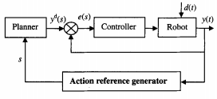

Figure 1: Event based control block – [9]

In this figure, ‘s’ denotes the true state of the robotic actuator, after a controller manipulates it to a goal state. Due to the time delay, without the feedback reference state which changes the desired input, uncertainty and unexpected results of the actuator cannot be corrected for by a change of plan. This block diagram outlines that if a desired state sent, a controller can be used correct for disturbances and achieve the goal actuation position, but the result of this action is required to check that if the final state is that of which is desired. In this way, asynchronous, or multiple, commands can be sent to a robotic arm remotely, and the actuator’s end state changes the next desired state.

**Remote Application Manipulation**

**Remote application programming interfaces (API) allow the manipulation of a program from a different location / system. This is typically done through a socket connection, which allows functions to access parts and features of an application; an example of an API is, google maps planted on a webpage (external to google). A distinct benefit of remote API’s from a programmer’s prospective is that the client platform can be built by any language, as long as the data is readable by the host machine; the host is the system of the API engine, where the application runs, and the client is the program sending commands. A noticeable drawback with remote API’s comes from the client different network configurations, and the permissions the operating system’s firewall or network adapter has with regard to retrieving information from a network of different configuration.**

**A Brief on Robotic Simulators – V-REP and Gazebo**

**There is a strong demand for dynamic simulators, for the aforementioned tasks and more. These simulators are more complex than video-game platforms as they need to adhere more strongly to the laws of physics, especially when collisions or human manipulation is included. It is for this reason that simulators come with a variety of dynamics / physics engine add-ons; such as ODE and Bullet. Not all platforms are open-source, and source code or documentation not easily accessible, thus it was for this reason that a comparison between simulators is dependent primarily on user feedback** [10]**. Through a survey of 119 participants, cited by** [10]**, it was concluded that 39% of them hadn’t heard of V-REP compared to that of 15% for Gazebo and 10% for ODE, yet 5% of participants current use V-REP compared to 13% and 11% for Gazebo and ODE respectively. In addition to this, it was found that V-REP was most preferable for research use. Gazebo is similar to V-REP as it is a multi-robot simulator with built-in support of ODE and Bullet dynamic engines, however, it’s used to model outdoor environments. Thus, the survey concluded that Gazebo was the most used simulation platform, however V-REP was the most preferred by the users who had tried it, and was rated higher for its extensive tutorials, support and documentation. Similarly to these findings, a comparison between Gazebo and V-REP simulators was performed by** [11]**, who concluded that V-REP was preferred due to its lower CPU demand, usability and vast external functionality, however Gazebo was found to be more heavily supportive of ROS.**

# Background of Project Related Material

## V-REP

V-REP is a robotic simulator by Coppelia Robotics, which provides manipulation and physical simulation of all objects in a scene by embedded scripts or API engine. Below is a quick brief on V-REP’s extended functionality:

* There are size different methods to externally control a scene; embedded scripts, add-ons, plug-ins, ROS node, remote API clients, ROS node and custom client/server configurations. Each of these have their own limitations in terms of delay and control [12].
* Compatible remote API languages include C/C++, Python, Java, Matlab, Octava, Lua and Urbi; each have their own libraries (100+ functions), example code and tutorials to ensure the user has the required support to connect to VREP remotely [13].
* For sending information via remote API, there are four different operation modes; blocking function calls, non-blocking calls, data streaming, and synchronous operation. Each has their own data flow that affects delay and reliability.
  + Blocking function calls – when a command is sent to the remote API server from a client, V-REP receives the command and sends back a return status. This enables the client program to identify if a problem has occurred with respect to the function call.
  + Non-blocking function calls – when a return status isn’t required from the API client, and thus there are no execution delays between requesting information, or calling a function. This is useful for when the client needs to send several requests of information in one message; for example, requesting for all the joint positions on a robotic arm can happen in one transmission rather than individual transmissions.
  + Data streaming – Data can be streamed from the server for a certain length of time or continuously, thus giving the client updated information on an object within the simulation, as requested prior.
  + Synchronous operation – remote API functions are executed asynchronously during a simulation by default, thus the simulation will continue without the client on an irregular basis. Thus, the progression of the simulation can be coordinated with the client via the synchronous stepping mode. Controlling the environment in this manner can lead to complications in data reading, if the client and simulation become out-of-sync, such that the wrong data is read by the client.
* Bullet Physics Library, Open Dynamics Engine, Vortex by CM Labs, and Newton Dyamics are the four dynamic engines currently supported by V-REP. Each one has its own method of calculating dynamics to mimic the real world, and thus it may be more advantageous to use one engine over another depending on the type of task being performed. By default, Bullet Physics Library is enabled, which is similar to gaming dynamic engines, allowing 3D collision detection and rigid body dynamics. Vortex Dynamics engine however can be used to model more realistic physical interactions, offering a closer depiction of real-world parameters. It is recommended to use V-REPS built-in kinematics ability with Bullet Physics Library, as computing purely off a physics engine for a realistic simulation can be slow and in some cases be imprecise; this would only be done if collisions need to be simulated in a realistic manner, i.e. the interactions between a gripper and object [14].
* CAD models can be imported into VREP, thus any object can be created and added to the scene as a collidable object. These models can then be edited to remove their internal material, or reconstruct the mesh, which beneficially reduces simulation time.
* All objects are scalable and
* Some extra features include collision detection (mesh to mesh), minimum distance between objects, inverse and forwards kinematics calculations, vision and proximity sensors, building block concept (build any system, including robotic arms), motion planning and data recording.

A detailed summary of V-REP’s features and functionality is available from [15], this as well as Coppelia’s documentation pages are a good source of information; and outline how to utilise these V-REP’s capabilities for a given task. For an understanding of V-REP’s simulation processes, below is a flow diagram, figure 2, which describes the interactions of important functionality.

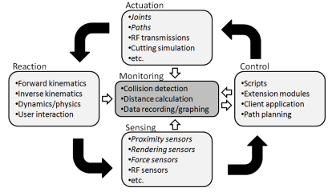

Figure 2 – V-REP’s simulation flow diagram [16]

## Kinova

Kinova is a Canadian based company whom develop robotic systems for personal use; more noticeably in rehabilitation, however also for research [17]. The Jaco arm is a lightweight 6 degree of freedom robotic arm designed by Kinova to assist people with upper body disabilities. Jaco2 is carbon fibre, weighing 4.4Kg, and can be fixed to wheelchairs or almost any surface by its aluminium base [18]. The key difference between the new Jaco edition and its former is the gripper, which includes a friction pad which helps in grasping fragile objects. A Kinova joystick can be used to control the arm’s translation, rotation and gripper, where the Singularity Avoidance System ensures the joints actuate in a desired manner. An additional feature is that the Jaco arm is compatible with Kinova’s software development kit (SDK), of which the API is accessed through USB 2.0 [19]. This enables programmers to control the actuation and access the arm’s advanced features. The SDK is compatible with Windows 7 and 8, as well as Linux Ubuntu, and a full programming guide is available for using the C++ API; with included tutorials and example code to get the programmer communicated and retrieving information from the arm [20].  
From the arm’s programmable documentation, it can be seen that the current position can be recorded, the arm can be made to move to a predefined position, it can rotate or translate about any of the 3D axis, and the gripper can open or close all of the gripper fingers. With the use of API functions, the arm can be made to move with respect to a Cartesian coordinate system, or by setting each joint angle individually; this can happen similarly in reverse, where joint angles is given to the programmer. The functionality can be driven further with trajectory planning and force control; similar to V-REP. All of the information from the arm is stored in an activity log, accessible in the API directory.

# Project Plan

## Current Objectives

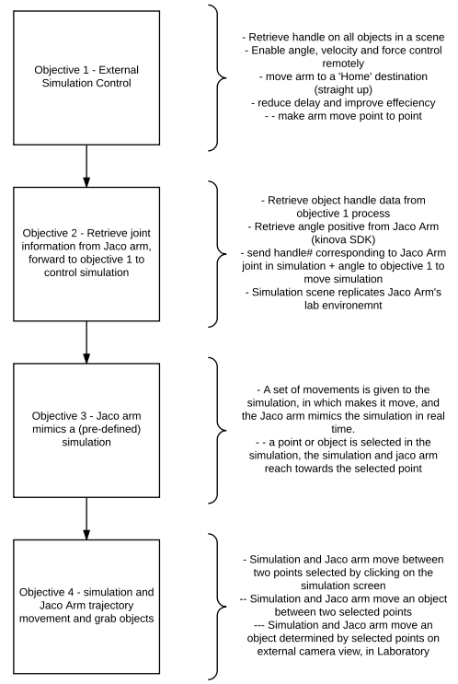There are four main objectives associated with this project, as described in figure 3; extension objectives from these may occur, or the main objectives may change slightly, but the overall structure is defined here. The main goal is to be able to easily use the simulation to manipulate the physical laboratory environment using the Jaco arm. This is done, firstly, by constructing an interface that can manipulate a simulation environment; objective 1.   
Objective 1 needs to be configured in such a way that it automatically retrieves the object handles (or object names) associated with the Jaco arm and gripper, and stores them in an external file every time it is run. This allows objective 2 to retrieve such information, retrieve joint angle information from the physical Jaco arm, and pipe back joint handles (or simulation object joint names) with the corresponding angles.   
The program developed in objective one should be configured to receive this information and move the simulation (Jaco arm) to a position which mimics that of the (physical) Jaco arm. With enough delay reduction from objective 1, this should be close to ‘real time’ and allow the physical movement of the Jaco arm be mimicked in   
the simulation; where the scene   
environments are the same.  
Following from this, objective 3 is to allow the operation of objective 2 occur in reverse. This may require a script based of objective 1 in reverse be generated; such that simulation manipulation with a mouse is abled and recorded. Information from the simulation can be piped to a process which manipulates the physical arm accordingly. Objective 4 is an extension from this which enables the simulation to detect objects be selected and moved from one point to another, with the physical arm replicating the action. Furthermore, using a video of the real scene (and a camera placed in a similar manner in the simulation, allowing interface from objective 3) a point can be clicked on the video footage and the arm will appear to move to the points in both simulation and reality.

Figure – List of project objectives and brief descriptions

## Possible Developments

Although this thesis is about creating an interface between a Jaco arm and V-REP simulator, to allow real-time movements be generated remotely, from these objectives there are a couple further developments that could be made possible;

* Virtual learning and distance education can entail a more interactive experience. For instance, if a teacher wanted to point out something in a student’s work, or potentially write something in front of them, they can do so by clicking on their video call window. This could enable a simulation arm platform to calculate the angles required by the appropriate to execute the task, and through remote API, a physical arm at the student end could interact with them. Alternatively, the teacher could move the simulation, which replicates the student’s environment, thus allowing the physical arm to mimic the movement. This process is simular to how surgeons are able to perform tasks on patients, when they are in different locations, but instead of the surgeon’s actions being recorded, a 2D to 3D mapping occurs with the help of the simulator. Thus, only the experience only requires two computers and a robotic arm; as the outcome is less complex in comparison with remote surgery of course.
* Physical laboratory work can be trialled without the physical arm to ensure the process will work. This is similar to the manufacturing industry, however could also allow real-time replication between simulation and physical environments. Thus, one could simulate a task, watch it be undertaken in the simulation knowing its working the same way in the laboratory.

## Process

### Objective 1

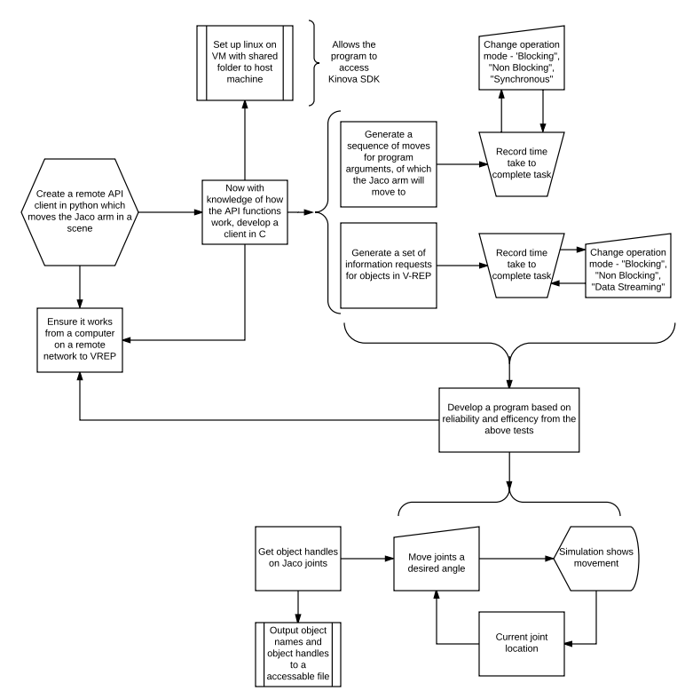

## Milestones

# Risk Assessment

# Discussion

# Conclusion

# Bibliography

|  |  |
| --- | --- |
| [1] | “Benefits and Costs of Process Simulation,” Modern Machine Shop, 15 February 2000. [Online]. Available: http://www.mmsonline.com/articles/benefits-and-costs-of-process-simulation. |
| [2] | “Process Simulate,” Siemens PLM Software, 2017. [Online]. Available: https://www.plm.automation.siemens.com/en/products/tecnomatix/manufacturing-simulation/assembly/process-simulate.shtml. |
| [3] | S. Fred M. Valerino, D. Sweetak and J. Osborne, “Parenteral products automation system (PPAS)”. Patent US5805454 A, 8 September 1998. |
| [4] | J. Rosen, B. Hannaford and R. M. Satava, “Surgical Robotics - Systems Applications and Visions,” Springer, University of California Santa Cruz, 2011. |
| [5] | P. Garcia, *Surgical Robotic Cell - Operating room without people,* Menlo Park, California: SRI International, 2008. |
| [6] | “The da Vinci Surgical System,” Intuitive Surgical Inc, 2017. [Online]. Available: http://www.davincisurgery.com/da-vinci-surgery/da-vinci-surgical-system/. |
| [7] | D. Obenshain and T. Tantillo, “Distributed Systems and Networks Lab - Remote Telesurgery,” [Online]. Available: http://www.cnds.jhu.edu/~dano/RemoteTelesurgery.pdf. |
| [8] | T. Simonite, “The Recipe for the Perfect Robot Surgeon,” Technology Review, 14 October 2016. [Online]. Available: https://www.technologyreview.com/s/602595/the-recipe-for-the-perfect-robot-surgeon/. |
| [9] | L. Xiao-ming, Y. Can-jun, C. Ying and H. Xu-dong, “Hybrid event based control architecture for tele-robotic systems controlled through Internet,” 11 September 2003. [Online]. Available: https://link.springer.com/article/10.1007%2FBF02841014?LI=true. |
| [10] | S. Ivaldi, V. Padois and F. Nori, “Tools for dynamics simulation of robots: a survey based on user feedback,” 27 February 2014. [Online]. Available: https://arxiv.org/pdf/1402.7050.pdf. |
| [11] | L. Nogueira, “Comparative Analysis Between Gazebo and V-REP Robotic Simulators,” [Online]. Available: http://www.dca.fee.unicamp.br/~gudwin/courses/IA889/2014/IA889-02.pdf. |
| [12] | “Writing code in and around V-REP,” Coppelia Robotics, [Online]. Available: http://www.coppeliarobotics.com/helpFiles/en/writingCode.htm#sixMethods. |
| [13] | “Remote API,” Coppelia Robotics, [Online]. Available: http://www.coppeliarobotics.com/helpFiles/en/remoteApiOverview.htm. |
| [14] | “Dynamics,” Coppelia Robotics, [Online]. Available: http://www.coppeliarobotics.com/helpFiles/en/dynamicsModule.htm. |
| [15] | E. Rohmer, S. P. N. Singh and M. Freese, “V-REP: a Versatile and Scalable Robot Simulation Framework,” [Online]. Available: https://www.researchgate.net/profile/Eric_Rohmer/publication/261352390_V-REP_A_versatile_and_scalable_robot_simulation_framework/links/54720e120cf216f8cfadb08b/V-REP-A-versatile-and-scalable-robot-simulation-framework.pdf. |
| [16] | M. Freese, S. Singh, F. Ozaki and N. Matsuhira, “Virtual Robot Experimentation Platform V-REP: A Versatile 3D Robot Simulator,” [Online]. Available: http://robotics.itee.uq.edu.au/~spns/pubcache/simpar2010.vrep.pdf. |
| [17] | “Kinova,” Robotnik, [Online]. Available: http://www.robotnik.eu/kinova/. |
| [18] | “KINOVA JACO² arm,” Robotnik, [Online]. Available: http://www.robotnik.eu/robotics-arms/kinova-jaco-arm/. |
| [19] | “Kinova Robotics - Jaco 6 DOF Technical Specifications,” 2014. [Online]. Available: http://www.robotnik.es/web/wp-content/uploads/2014/04/JACO2_Brochure1.pdf. |
| [20] | Kinova, “Jaco API Programming Guide,” 10 April 2014. [Online]. Available: http://www.ee.oulu.fi/~sunday/jaco/JacoAPI_ProgrammingGuide.pdf. |